**TOPIC 3: DIVIDE AND CONQUER**

**EXPERIMENT 3.1**

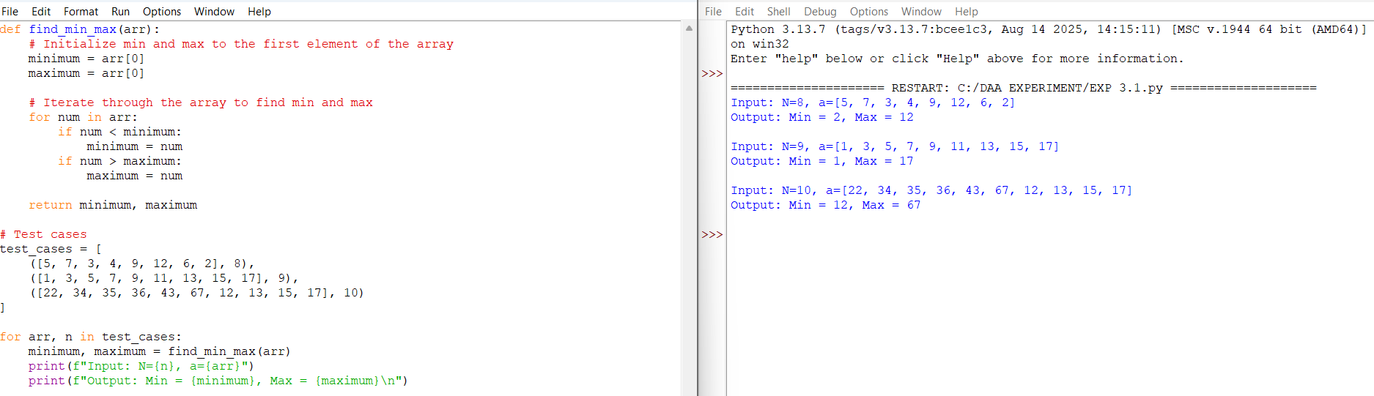

**EXPERIMENT 3.2**

**EXPERIMENT 3.3**

**EXPERIMENT 3.4**

**EXPERIMENT 3.5**

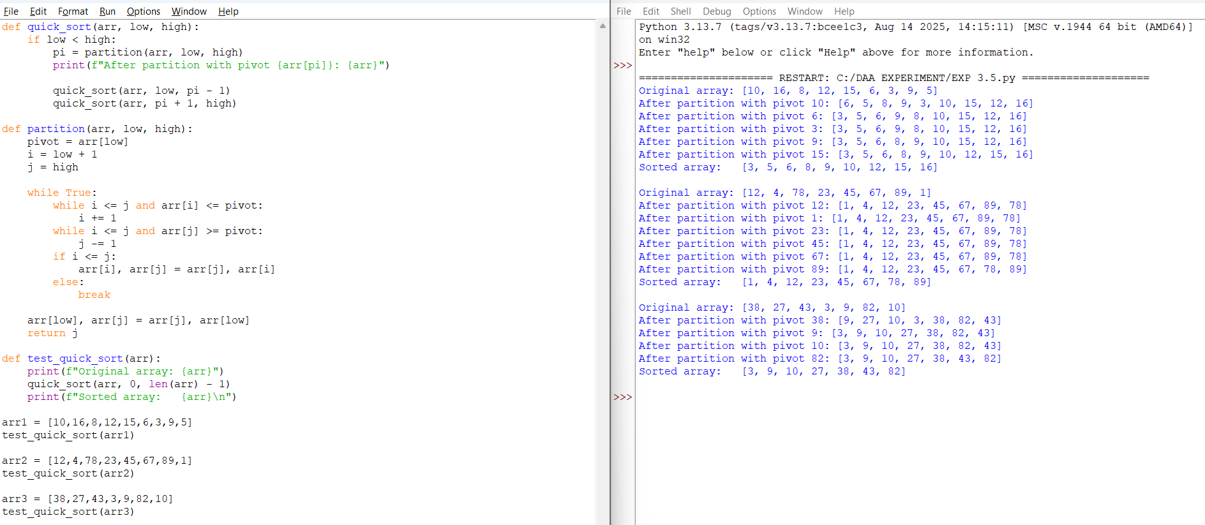

**EXPERIMENT 3.6**

**EXPERIMENT 3.7**

**EXPERIMENT 3.8**

**EXPERIMENT 3.9**

**EXPERIMENT 3.10**

**EXPERIMENT 3.11**

**EXPERIMENT 3.12**

**EXPERIMENT 3.13**

**EXPERIMENT 3.14**

**EXPERIMENT 3.15**

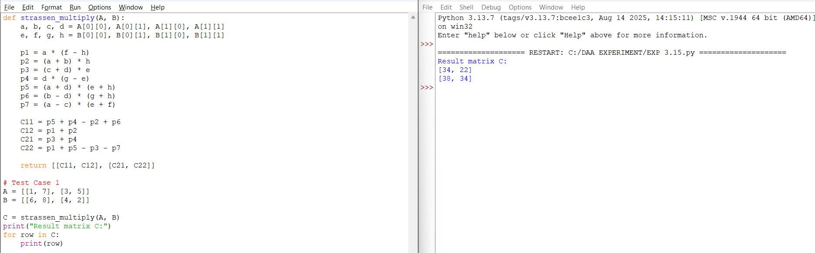

**EXPERIMENT 3.16**

